**Tabellen aanmaken**

|  |  |  |  |
| --- | --- | --- | --- |
| create table lectoren | | | |
| ( |  |  |  |
| LECTR_ID |  | , constraint LECT_LECTR_ID_FK | reference medewerkers |
| , SRT_ID | char(5) | constraint lect_SRT_ID_chk | check(to_number(substr(SRT_ID,2,2))between 10 and 30) |
| , STAT | number(5) | constraint lect_STATUUT_nn | not null |
|  |  | , constraint lect_STATUUT_fk | references statuut |
| , SALARIS | number(7,2) | constraint lect_SAL_chk | check(SALARIS < 1850.50) |
| , INDIENST | date | constraint lect_INDIENST_chk | check (months_between (date '2019-11-01', date '2019-11-30')=1) |
| , EINDDATUM | date | constraint lect_EINDDATUM_chk | check (ADD_MONTHS(date '2019-11-30',3)) |
| , AANWERVING | char(1) | Default 'J' |  |
|  |  | , constraint lect_AANWERVING_chk | check (AANWERVING IN('J', 'N')) |
|  |  | , constraint lect_pk | primary key(LECTR_ID, SRT_ID) |
| ); |  |  |  |

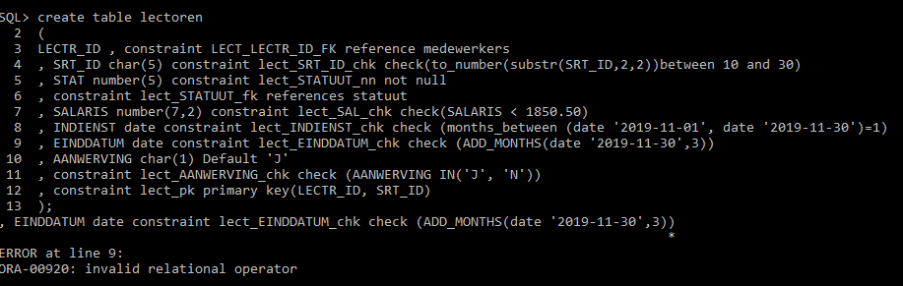

|  |  |  |  |
| --- | --- | --- | --- |
| create table statuut | | | |
| ( |  |  |  |
| STAT_ID | Number(5) | constraint STAT_STAT_ID_PK | Primary key |
| , STATUUT1 | Varchar2(25) | constraint STAT_STATUUT1_CHK | check(STATUUT1 < 20) |
| , STATUUT2 | char(15) | , constraint STAT_STAT2_CHK | check (STATUUT2 = (UPPER(STATUUT2))) |
|  |  | , constraint STAT_STATUUT2_CHK | check (STATUUT2 IN ('STATUUT1', 'STATUUT2')) |
| ); |  |  |  |

